Create an EFS and connect it to 3 different EC2 instances. Make sure that

all instances have different operating systems. For instance, Ubuntu, Red

Hat Linux and Amazon Linux 2.

1. **Created Ubuntu Instance**

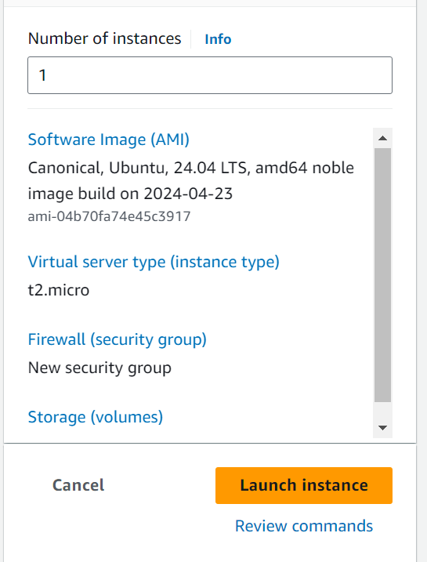

1. **Created RedHat Instance**

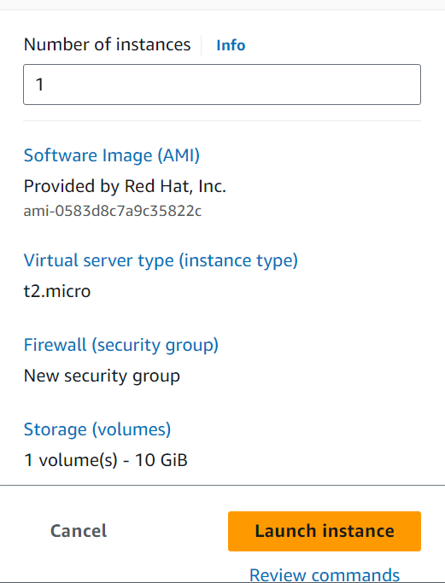

1. **Created Amazon Linux Instance**

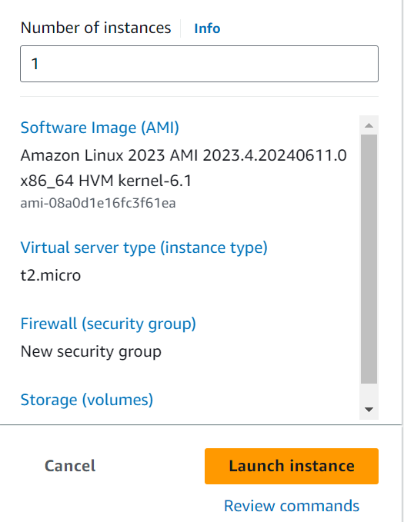

1. **Created EFS**

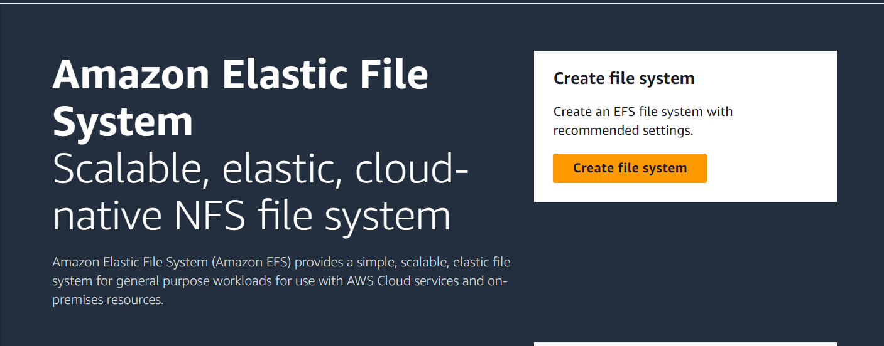

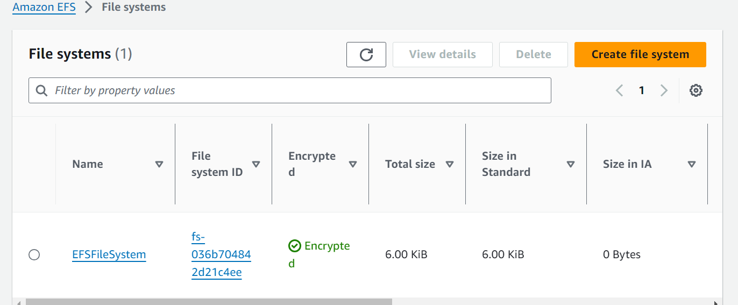

**Now will attach the EFS to all instances and share the files.**

1. **Connect to Ubuntu Instance**

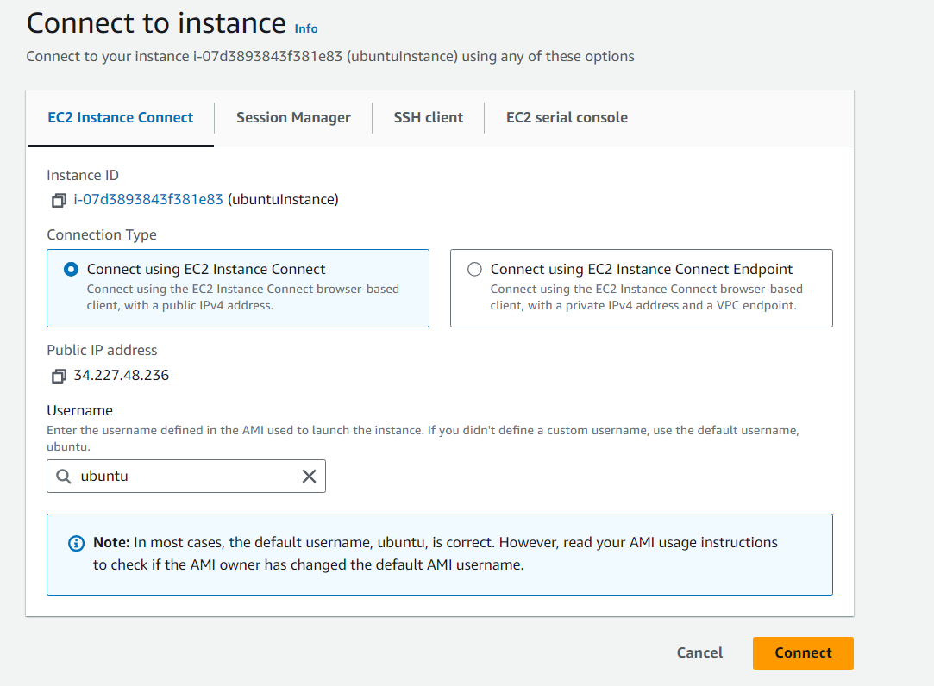

Update the package Information

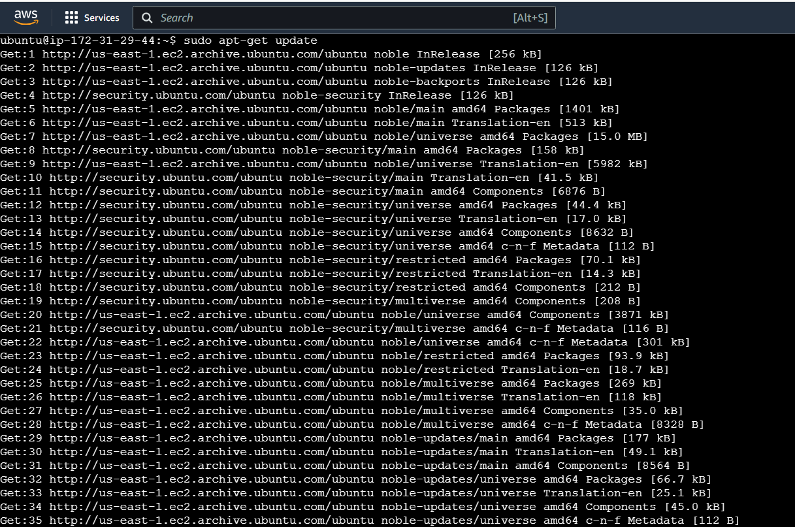

Created the directory efs1

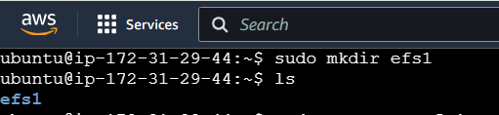

Installed the NFS Protocol as EFS works on NFS Protocol

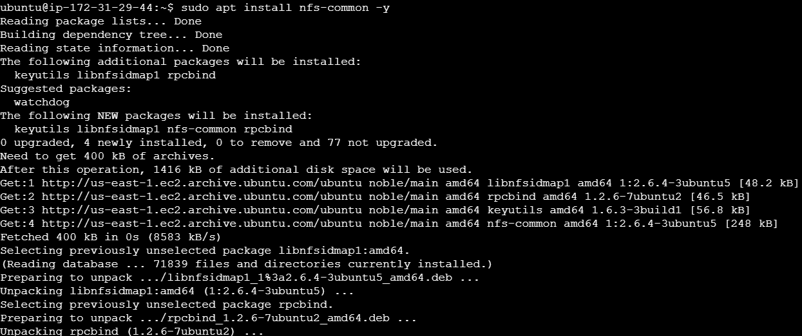

Now attach the EFS to Ubuntu instance. For that need to take command from the EFS attach tab

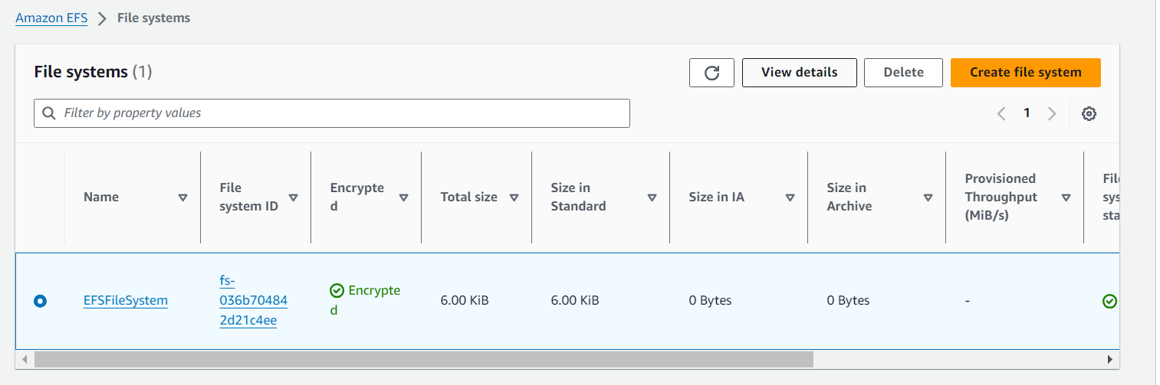

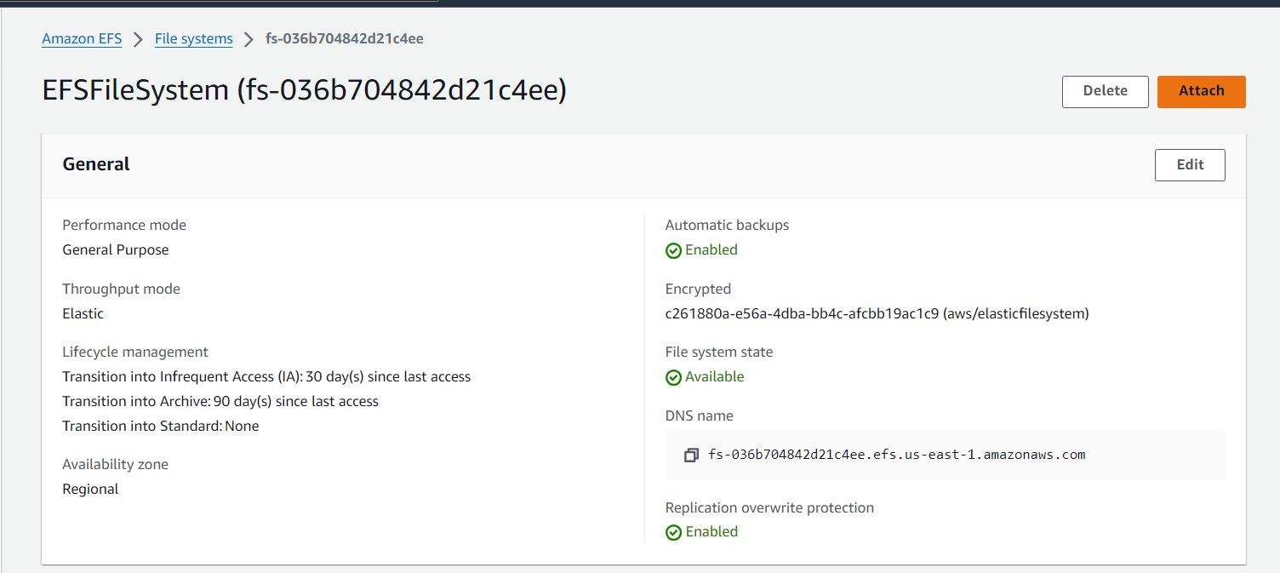

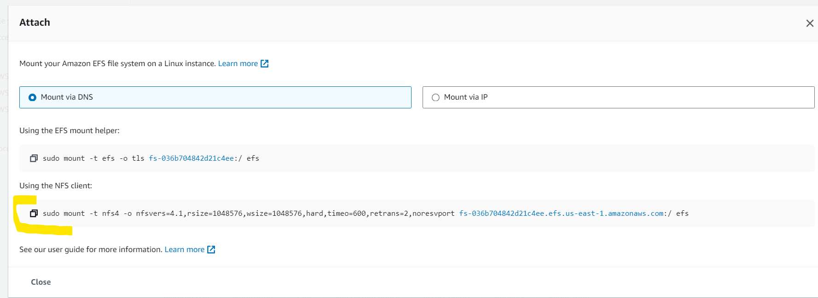

Paste the command and changed the directory name to efs1 once done went to the directory and created the file 1.txt

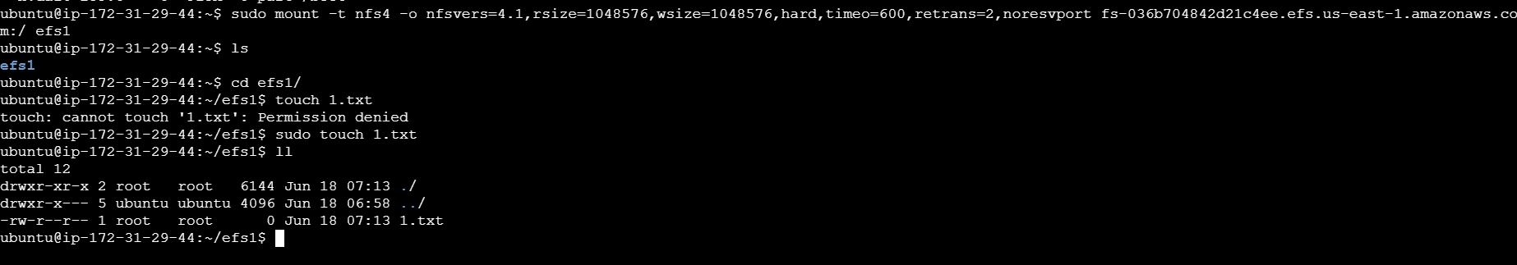

Now the 1.txt file will be available to other instances once EFS is attached to those instances.

1. **Connect to Linux Instance**

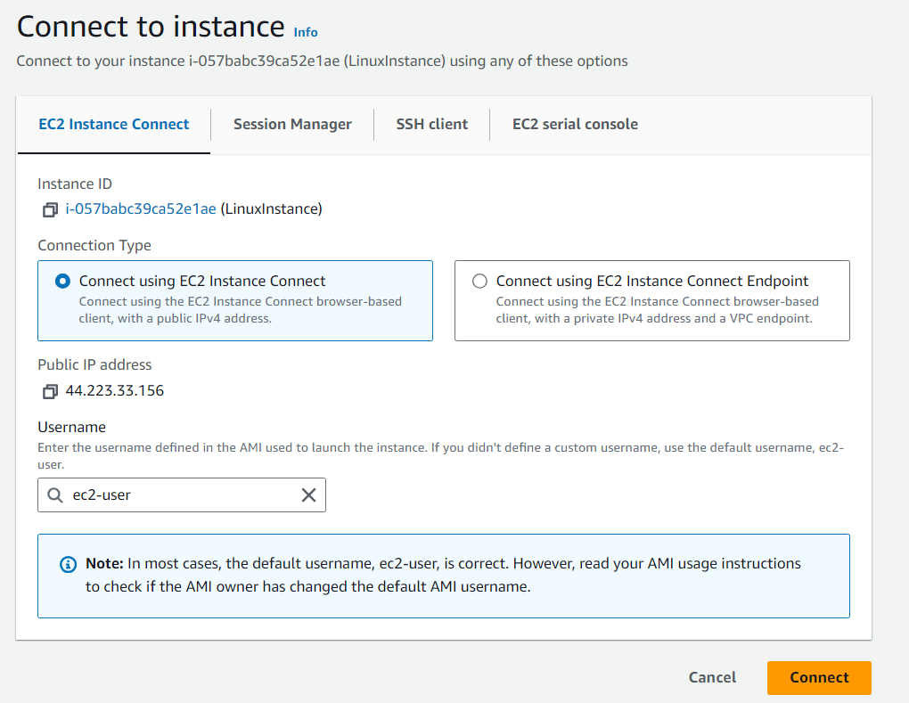

Update the package information. created the directory efs2 and the same EFS is mounted on linux instance as result it shows the 1.txt which was created in ubuntu instance.

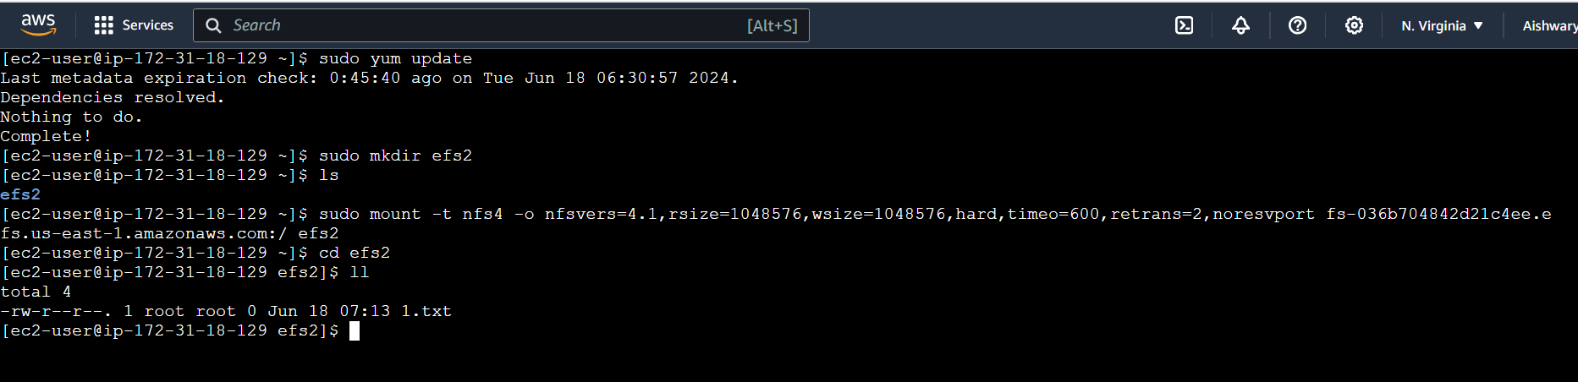

Now created file with name 2.txt now it will show 2.txt and 1.txt also.

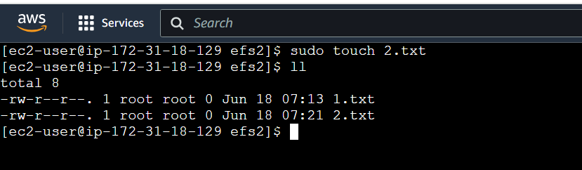

The 2.txt is available on ubuntu Instance. Because 2.txt was created in linux instance and EFS is mounted on both instances

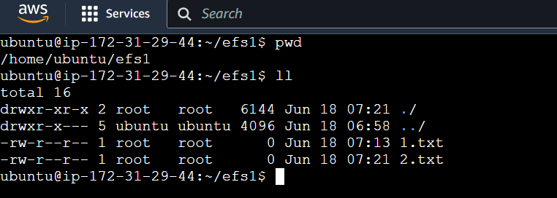

The files 1.txt and 2.txt will be available on RedHat instance once EFS is mounted to the RedHat Instance.

1. **Connect to RedHat Instance using putty application**

Take public IP of the Red hat instance

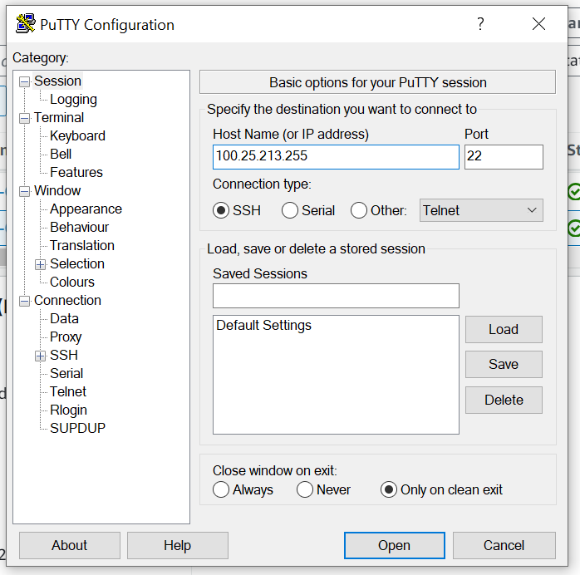

Go to below path add the .ppk file and click on open. It will connect to the RedHat Instance

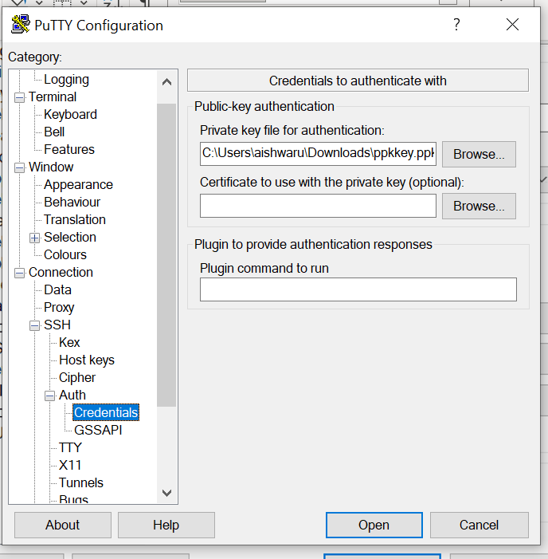

Now updated the package information.

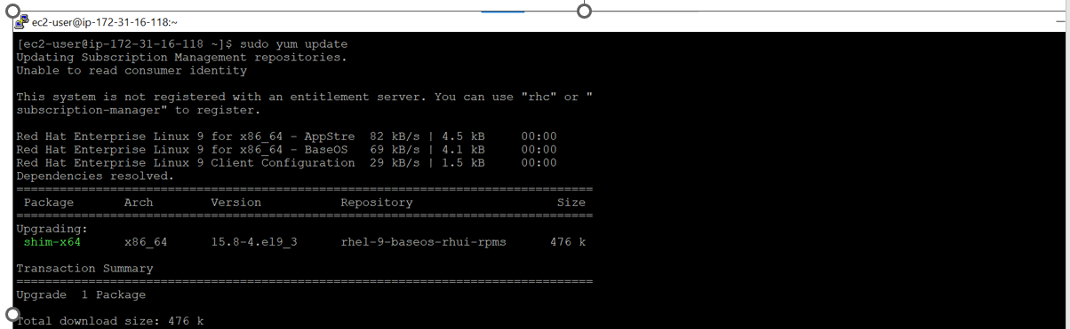

Install NFS protocol as EFS work on NFS protocol.

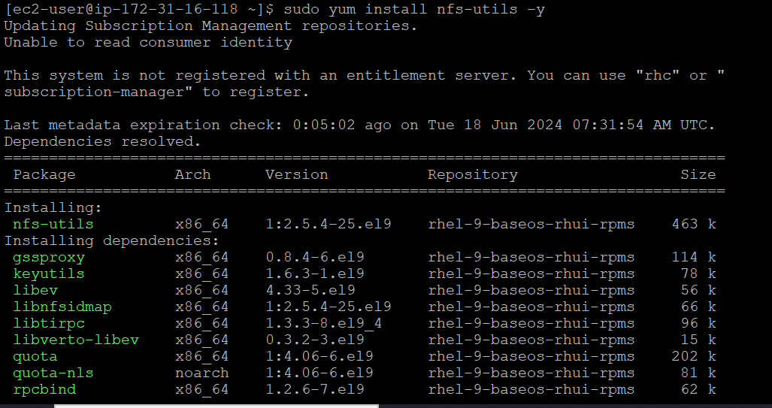

Create directory efs3 and mount the EFS. Now we will see 2 files are available 1.txt file from ubuntu Instance and 2.txt file from linux Instance.

